Big Data Lab-1

Suryanarayan.B

CB.EN.U4CSE19056

1) Display your current directory.

PWD

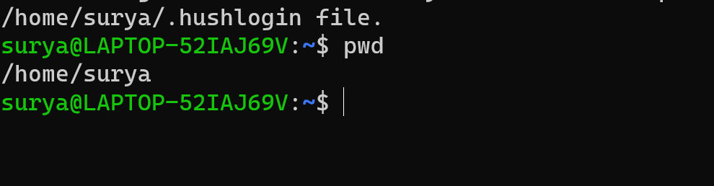

2) List the contents of the root directory.

cd /root/

ls -a

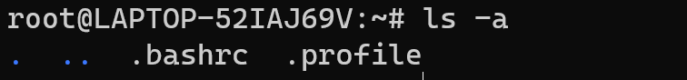

3)List a long listing of the root directory.

ls -la

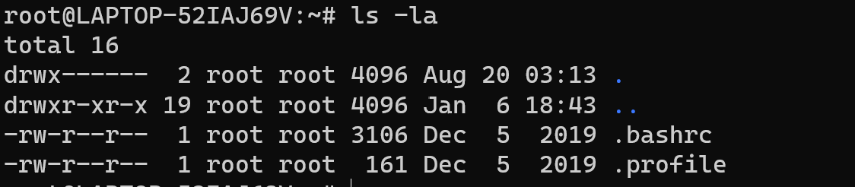

4) Stay where you are, and list the contents of /home directory.

ls /home/

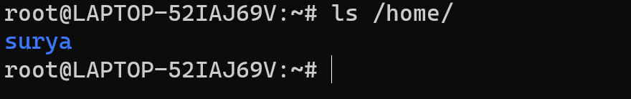

5) Create a directory testdir and sample in your own directory.

mkdir testdir

ls

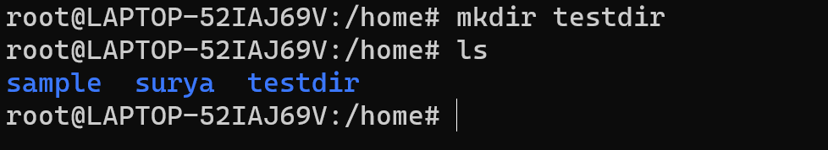

6) Create the files today.txt and yesterday.txt in folder all testdir folder

cat > yesterday.txt



cat >today.txt



7) Copy only the contents of testdir ( today.txt and Yesterday.txt) new directory sample

cp testdir/* anotherdir

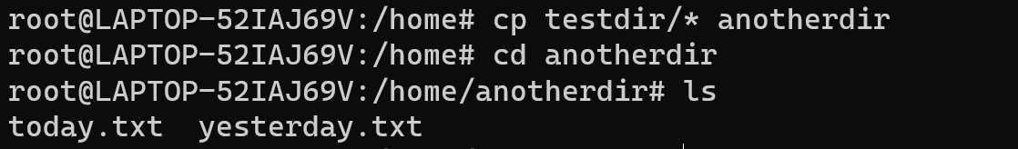

8) Move today.txt to your user directory

mv today.txt /home

cd ..

ls

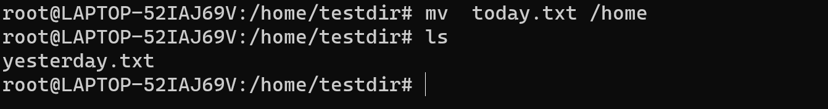

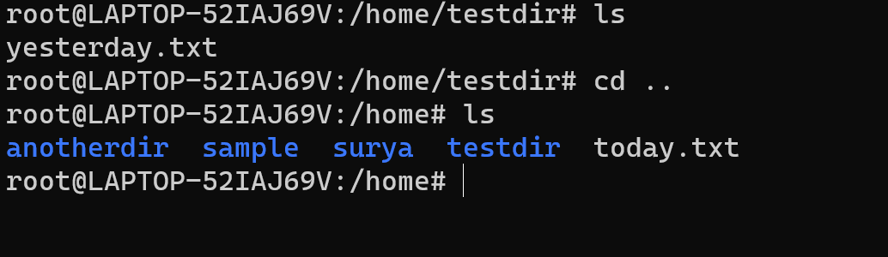

9) Remove the directory testdir

rm -r testdir

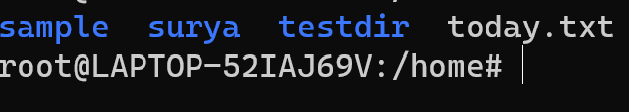

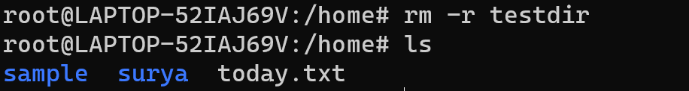

10) Display a list of all logged on users.

w

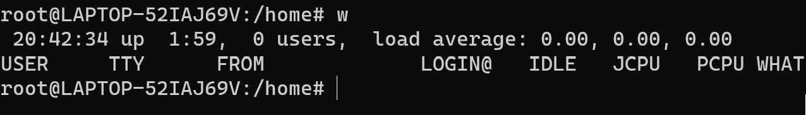

11) Create a user account named serena, including a home directory and a description (or comment) that reads Serena. Do all this in one single command.

useradd -m -c ‘Serena’ Serena

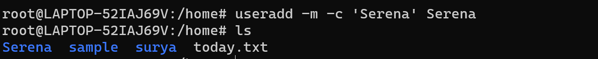

12) Come back to user user prompt :

Clear or ctrl+c

13) List the files with their access permissions for yesterday.txt Change the permission of file sample.txt to all users

Chmod -r yesterday.txt

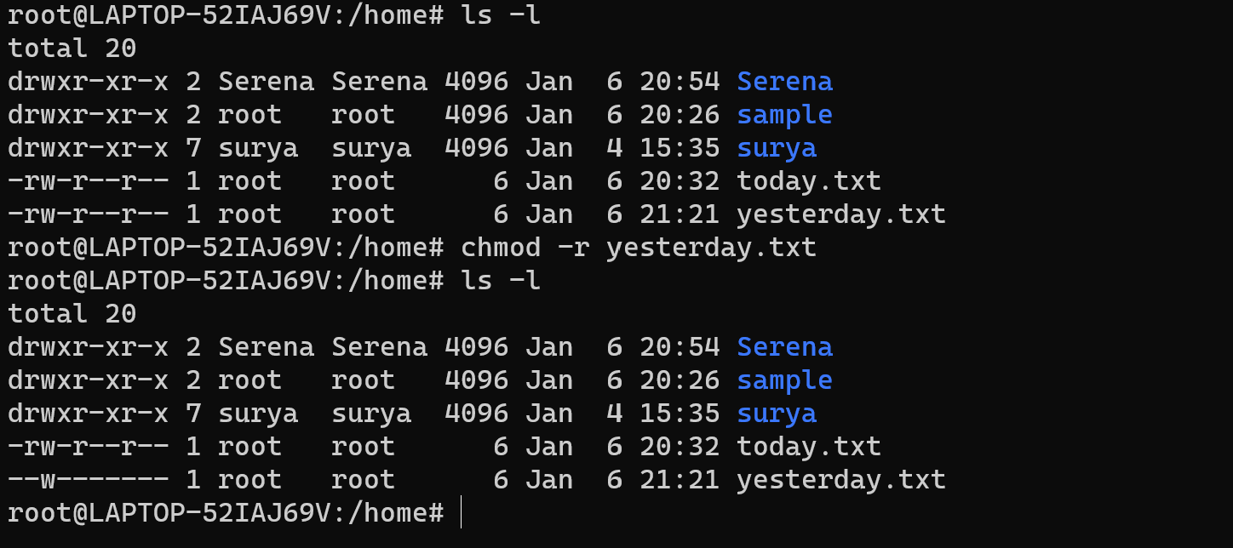

14) Give only read permission for group users in sample.txt file

Chmod g-w sample.txt

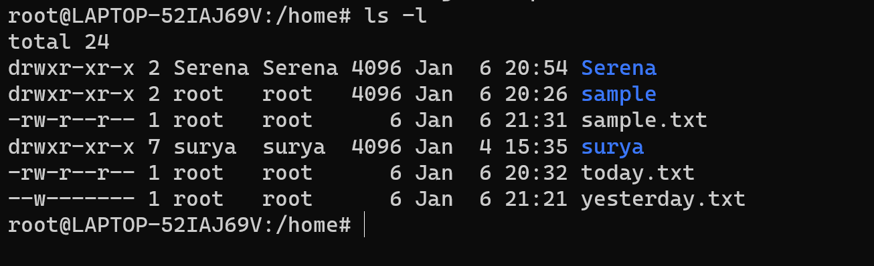

15) Find the difference between su and sudo command

* 1. ***This is a key difference between su and sudo. Su switches you to the root user account and requires the root account's password. Sudo runs a single command with root privileges — it doesn't switch to the root user or require a separate root user password***

16) Create the groups tennis

Groupadd tennis



17) In one command, make serena a member of tennis

Usermod -a -G tennis Serena



18) Delete Group

Groupdel tennis



19) Check the disk space of the system

df -H

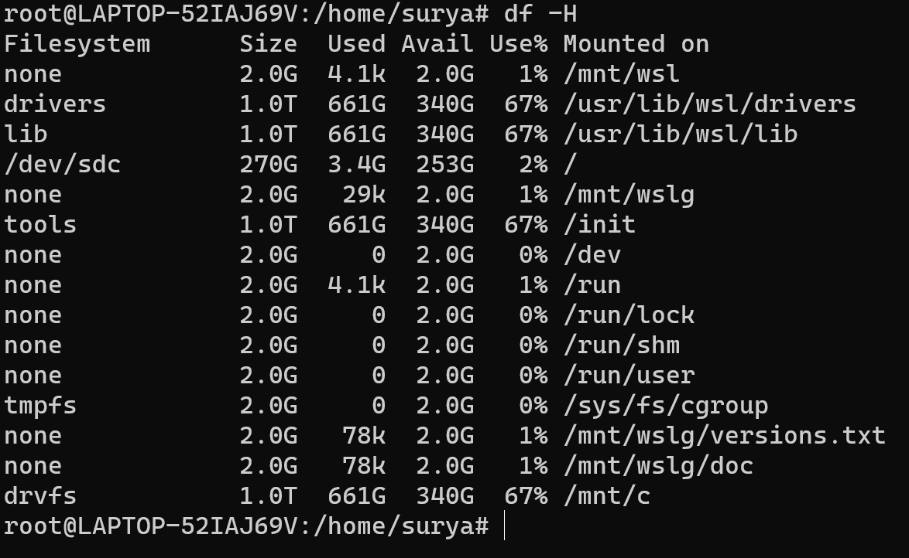

20) Check the system configuration.

lscpu

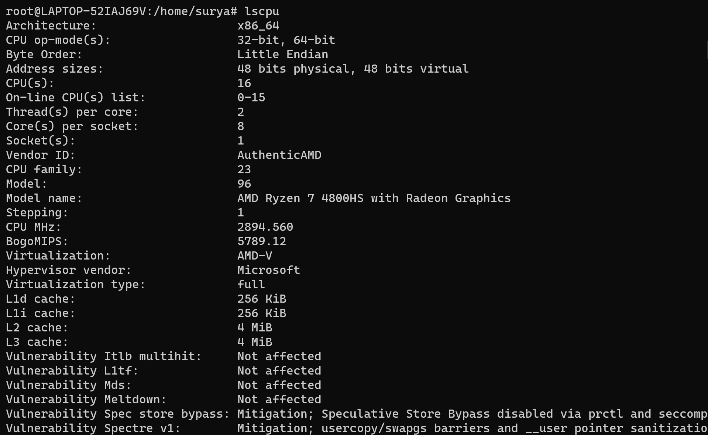

21) Zip a file and unzip a file

Zip sample.zip sample.txt

Unzip sample.zip

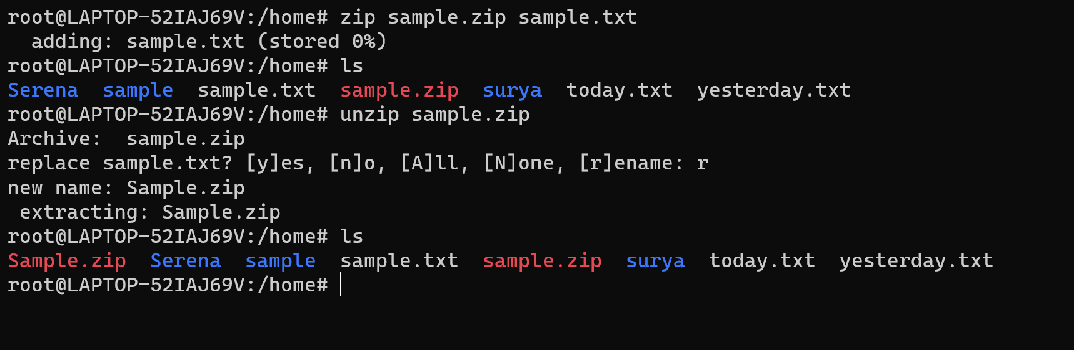

22) Search for files ending with .txt in a directory

ls *.txt

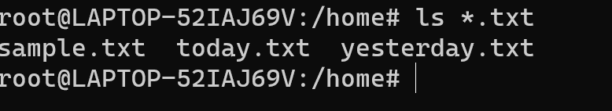

23) Find all instances of a file

find /home -name "*.txt"

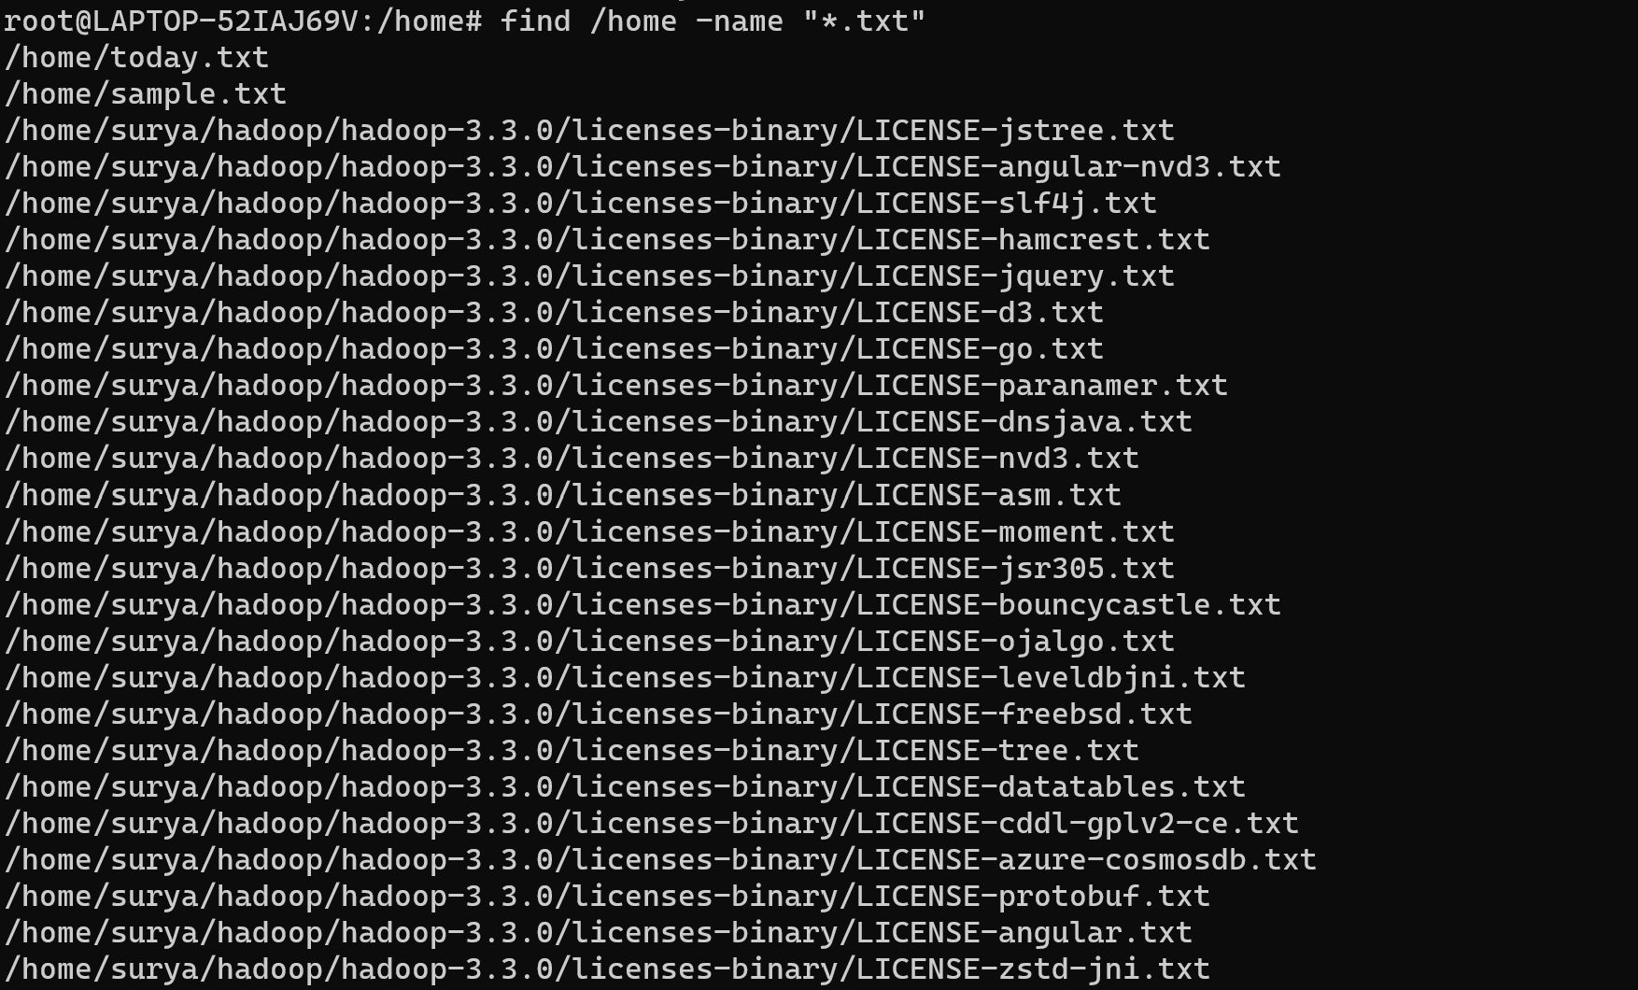

24) Create a file in your name and set the read write and execute permission for the file as 777

Chmod 777 surya.txt

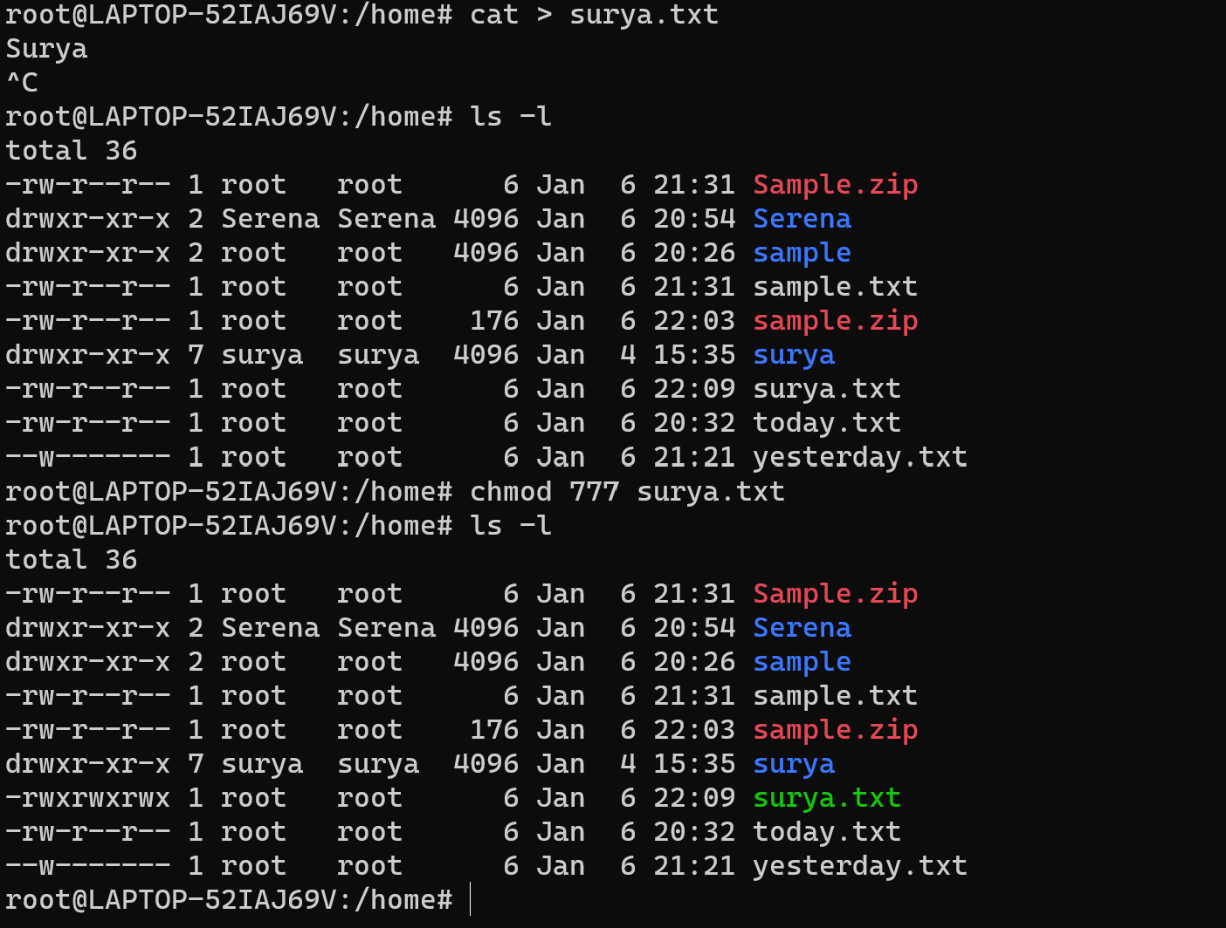

25) Find the details of your operating system

Cat /etc/os-release

